|  |  |
| --- | --- |
| **DOKUMENTASI EKSTERNAL**  External Documentation |  |
| **[TUGAS MANDIRI / PROYEK ]**  **[*Assignment / Project*]** |
| **MATAKULIAH <XX999> – <Human Computer Interaction>**  ***Subject*** |
| SEMESTER [GENAP] 2016/2017 ***[Odd/Even/Compact] Semester Year 2016/2017*** |

## Judul Proyek

*[Assignment / Project]**Title*

* **Jar Of Hope**

## Abstrak [50 – 200 words]

*Abstract*

**Jar of Hope** is a non-sectarian charity organization to help people in need. **Jar of Hope** was formed in December 16, 2013 and based on Jakarta, Indonesia. Our organization reflects our commitment to serves people who need help and give them a hope. **Jar of Hope** carefully selects projects which help communities thrive. At least 90% of the funds raised go directly to our charitable projects. As the growth of the information technology, **Jar of Hope** haveplan to create **website** that represent organization image. With this website existence, **Jar of Hope** hopes they can improve their service towards the people. By having some requirement, **Jar of Hope** entrust you as a web designer to design and create their **logo** and **company** **website**.

## Pendahuluan

*Introduction*

Pembuatan Jar of Hope ini dibuat oleh 4 mahasiswa binus. Web Page ini dibuat dengan menggunakan sublime text 3 dan photoshop cs 6 dalam pembuatan logo dan blueprintnya. Bahasa yang digunakan adalah HTML , JS , dan CSS.

## Dokumentasi

*Report / Documentation*

Home Page

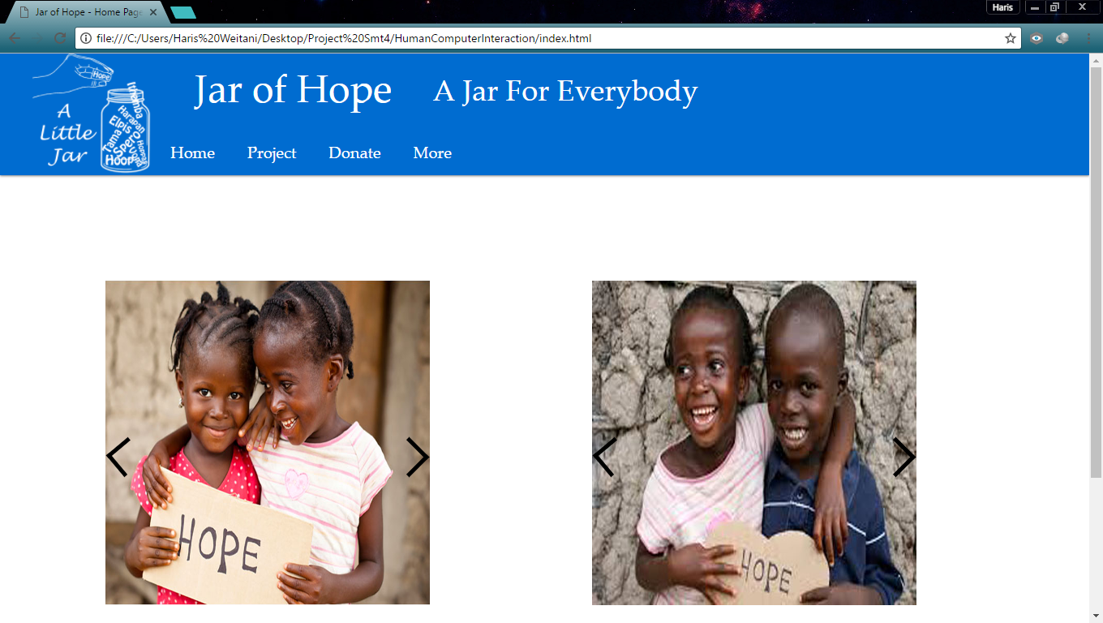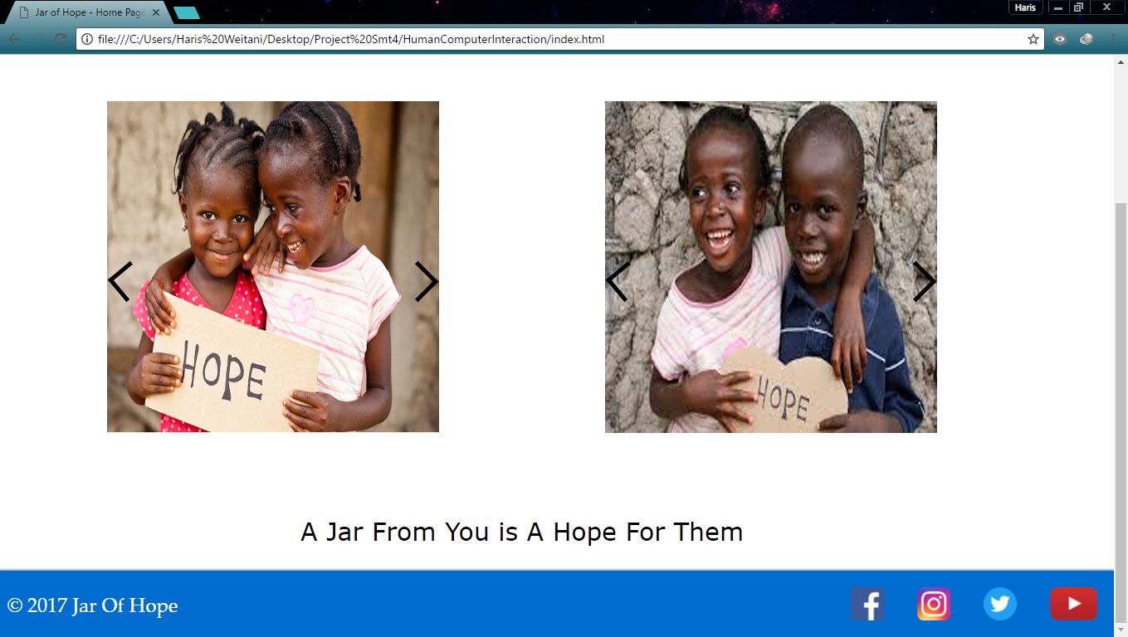

Page ini merupakan homepage dari Jar of Hope kami , disini terdapat 2 image slider

Pada footer juga terdapat copyright dan beberapa icon social media yang dapat digunakan

Project Page

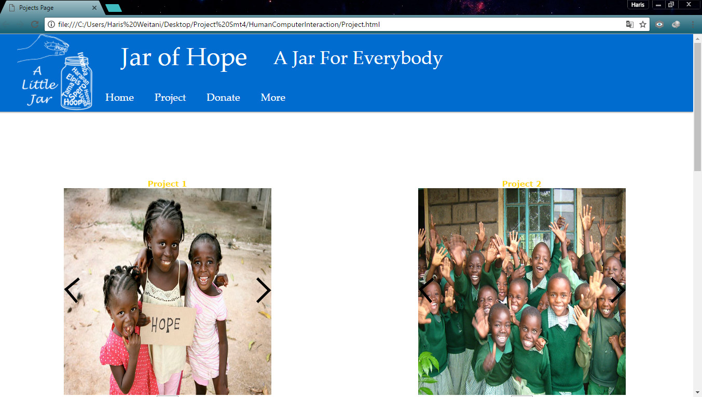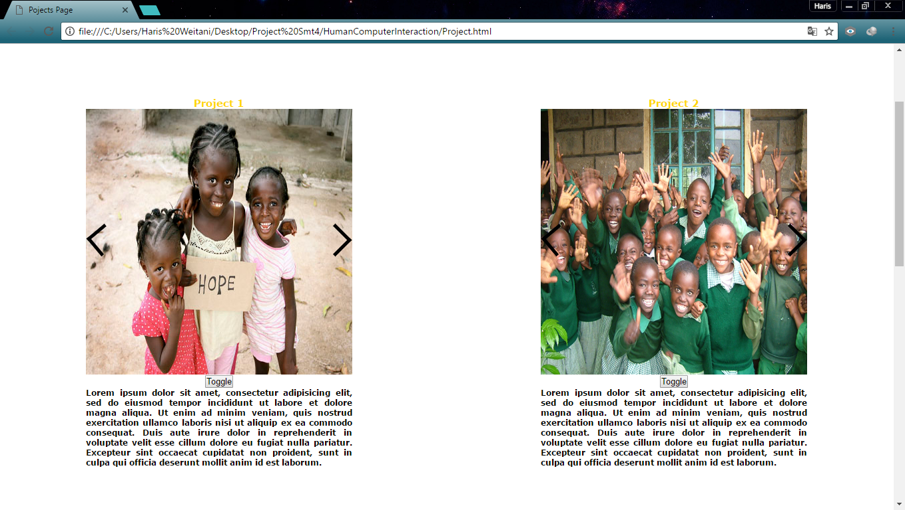

Pada page project ini terdapat tampilan project project yang Jar of Hope gunakan

Di page ini terdapat image slider dan toogle button untuk menyembunyikan dan memperlihatkan diskripsi yang ada

Donate Page

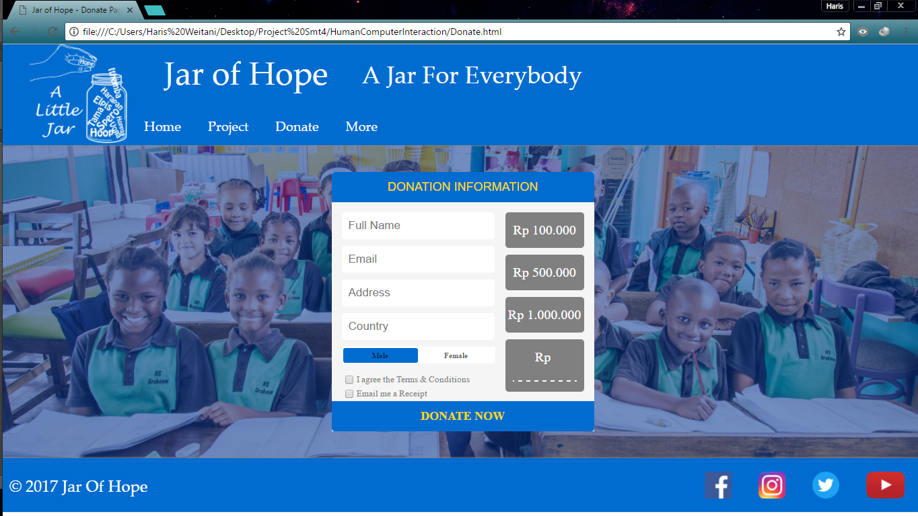

Pada donate page ini user dapat melakukan donasi kepada Jar of Hope yang nanti akan disumbangkan.

Disini terdapat form pengisian data diri dan juga beserta validasi

More Page

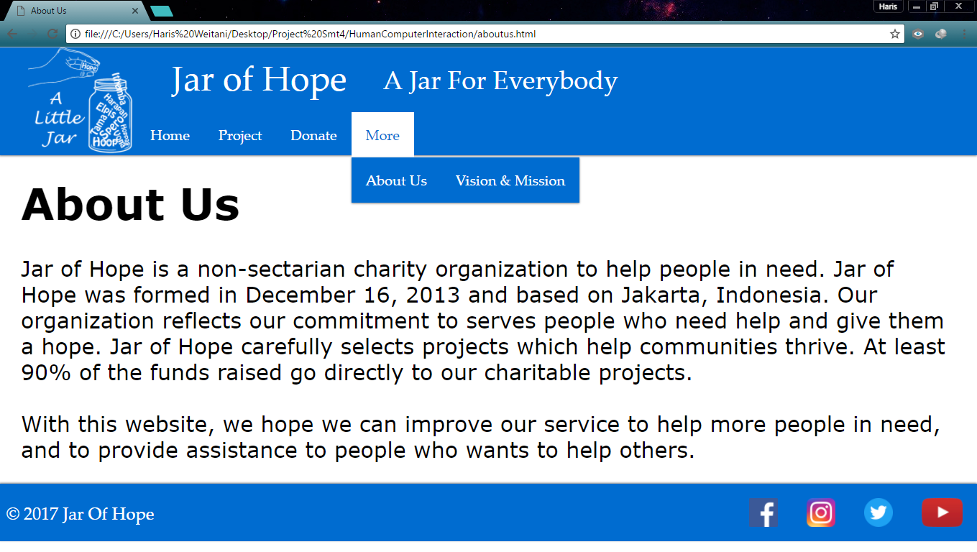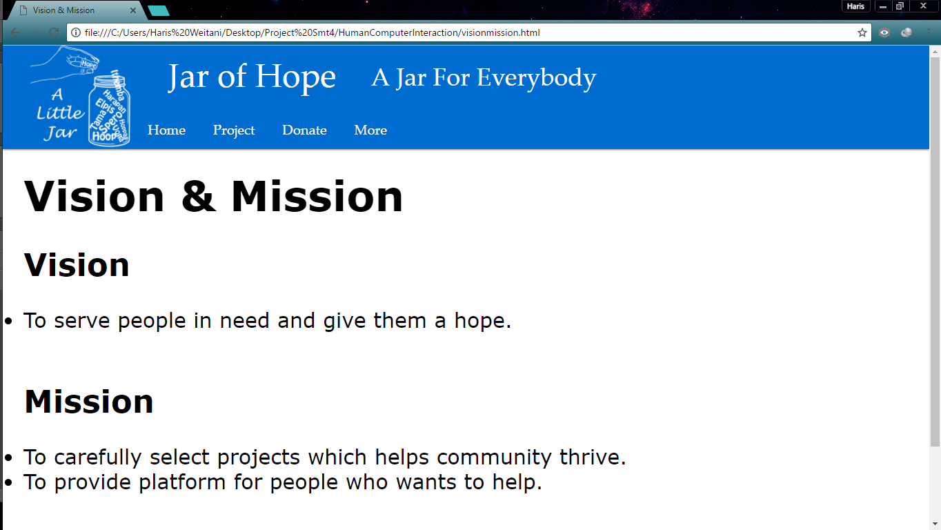

Page More ini bisa di drop down dan tedapat 2 menu lagi yaitu About Us dan Vision Mission

Responsive Page

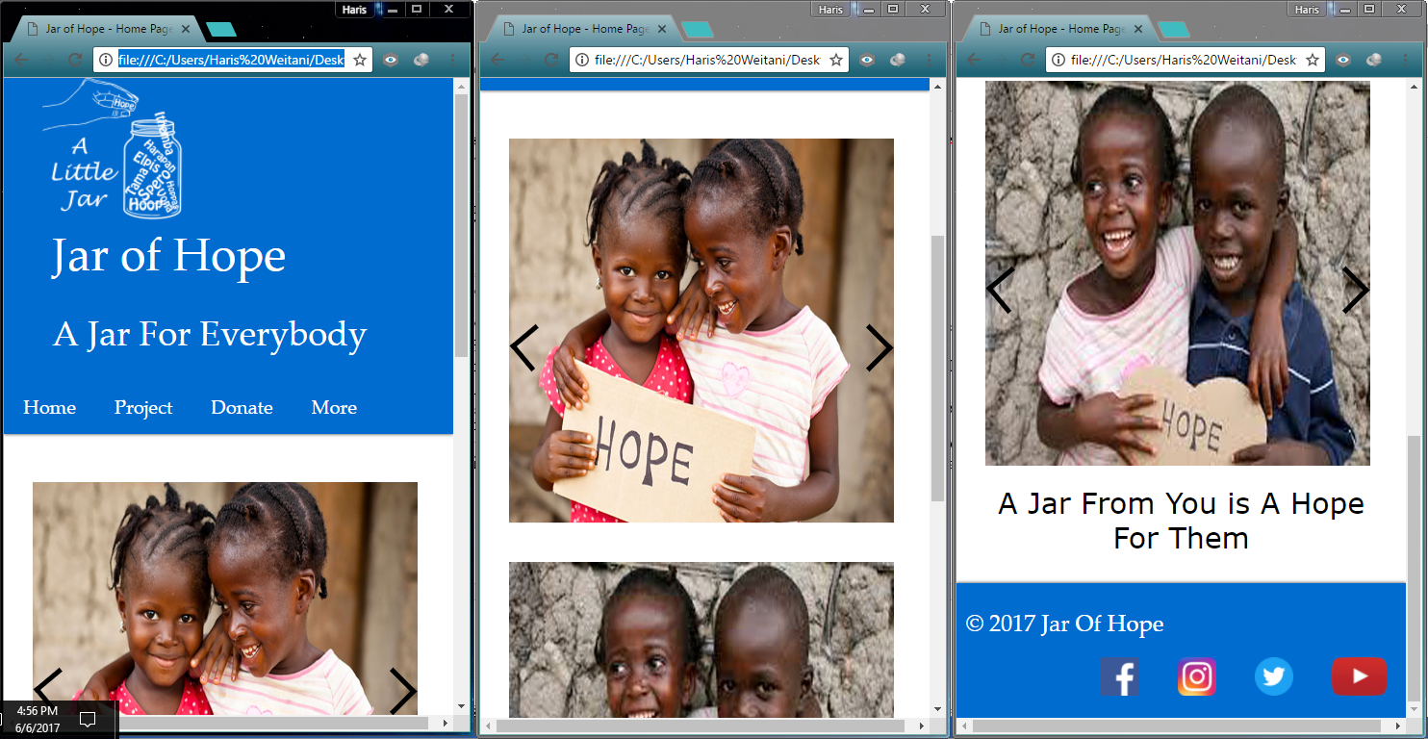

Semua page dari website ini bersifat responsive sesuai dengan ketentuan yang ada di soal

## Referensi

*References*

Logo

https://www.google.co.id/imgres?imgurl=https%3A%2F%2Fwww.canada.ca%2Fcontent%2Fdam%2Fcanada%2Femployment-social-development%2Fmigration%2Fimages%2Fassets%2Fportfolio%2Fdocs%2Fen%2Freports%2Fhealth_safety%2Fnarrow-pinch.jpg&imgrefurl=https%3A%2F%2Fwww.canada.ca%2Fen%2Femployment-social-development%2Fservices%2Fhealth-safety%2Freports%2Fergonomics%2Fmodule3.html%3F%3Dundefined%26wbdisable%3Dtrue&docid=78kMjWXPAxKEmM&tbnid=WJHWmHP7lFtoqM%3A&vet=10ahUKEwi37anwkIDUAhXFuI8KHRE4De8QMwgrKAswCw..i&w=588&h=325&safe=off&bih=629&biw=1360&q=simple%20hand%20drawing%20pinched&ved=0ahUKEwi37anwkIDUAhXFuI8KHRE4De8QMwgrKAswCw&iact=mrc&uact=8

https://www.google.co.id/imgres?imgurl=http%3A%2F%2Fdemandware.edgesuite.net%2Faamm_prd%2Fon%2Fdemandware.static%2F-%2FSites-joann-product-catalog%2Fdefault%2Fdw0a6e23e9%2Fimages%2Fhi-res%2F13%2F13922364.jpg&imgrefurl=https%3A%2F%2Fwww.tes.com%2Flessons%2FKrGwbgR7Yjy9Vg%2Fput-it-in-a-jar-don-t-bug-me&docid=9VYnZeT4n_SoPM&tbnid=x5_huvWgobhzPM%3A&vet=10ahUKEwiChsXvjoDUAhUDj5QKHeelAQEQMwg8KAMwAw..i&w=1105&h=1252&safe=off&bih=678&biw=1360&q=jar%20drawing&ved=0ahUKEwiChsXvjoDUAhUDj5QKHeelAQEQMwg8KAMwAw&iact=mrc&uact=8

Content

https://www.google.co.id/search?q=facebook+logo&safe=off&source=lnms&tbm=isch&sa=X&ved=0ahUKEwi90_m1pIDUAhWFpZQKHZYLDZYQ_AUICigB&biw=1360&bih=638#safe=off&tbm=isch&q=happy+african+children+with+hope&imgrc=MXY1-Q9lMd07NM:

http://www.sosafrica.com/getfile.php?w=61&type=site_images&id=Donate%20Image%201.jpg

https://www.google.co.id/search?q=happy+african+child&biw=1280&bih=711&noj=1&source=lnms&tbm=isch&sa=X&ved=0ahUKEwibj7zJmqLUAhVFPY8KHZY4D-gQ_AUICigB

https://www.google.co.id/search?biw=1280&bih=711&noj=1&tbm=isch&q=happy+african+child+at+school&sa=X&ved=0ahUKEwjzwNbKmqLUAhUBN48KHW2_DpgQhyYILQ#imgrc=nRj_g-12qjok1M:

https://www.google.co.id/search?q=happy+african+child+with+water&source=lnms&tbm=isch&sa=X&ved=0ahUKEwjUw_fGnqLUAhVEP48KHaztBNkQ_AUIBigB&biw=1280&bih=711

Footer

https://www.google.co.id/search?q=facebook+logo&safe=off&source=lnms&tbm=isch&sa=X&ved=0ahUKEwi90_m1pIDUAhWFpZQKHZYLDZYQ_AUICigB&biw=1360&bih=638#imgrc=mPeGAGNnyBu0iM:

https://www.google.co.id/search?q=facebook+logo&safe=off&source=lnms&tbm=isch&sa=X&ved=0ahUKEwi90_m1pIDUAhWFpZQKHZYLDZYQ_AUICigB&biw=1360&bih=638#safe=off&tbm=isch&q=twitter+logo+png

https://www.google.co.id/search?q=facebook+logo&safe=off&source=lnms&tbm=isch&sa=X&ved=0ahUKEwi90_m1pIDUAhWFpZQKHZYLDZYQ_AUICigB&biw=1360&bih=638#safe=off&tbm=isch&q=instagram+logo+png+transparent+background&imgrc=pfJG4ZtV7hOXVM:

https://www.google.co.id/search?q=facebook+logo&safe=off&source=lnms&tbm=isch&sa=X&ved=0ahUKEwi90_m1pIDUAhWFpZQKHZYLDZYQ_AUICigB&biw=1360&bih=638#safe=off&tbm=isch&q=youtube+logo+png+transparent+background&imgrc=Qc3LsyzOKZ2OLM:

Fonts

https://fonts.googleapis.com/css?family=Montserrat:400,700

https://fonts.googleapis.com/css?family=Droid+Serif:400,700,700italic,400italic

Disiapkan Oleh,

*Prepared by,*

* **<1901459693> - <Haris Weitani>**
* **<1901468294> - <William Salim>**
* **<1901459604> - <Glenn Vincen>**
* **<1901459711> - <Albert Miliano>**